Shutdown the server

Verify that both the Pick Server and the Pick Workstation are in ‘Stopped’ status.
Open the [Workstation] Tab
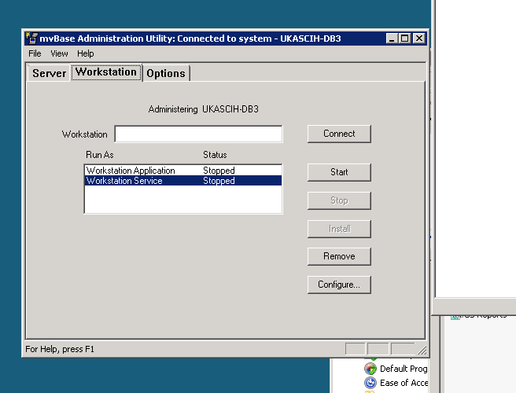
Choose the [Configure] button
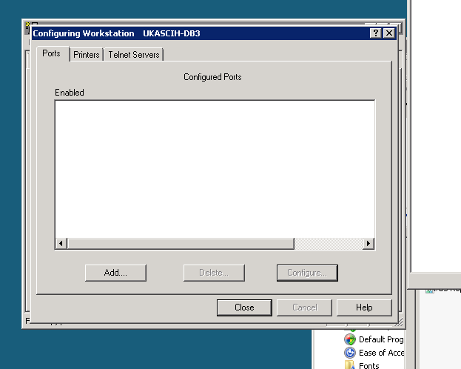
The Configure Workstation appears.
Choose the [Printers] tab

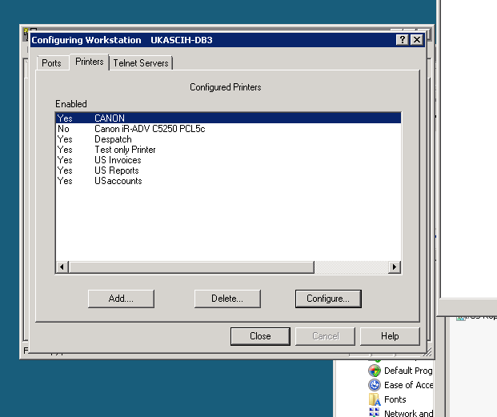
The list of existing printers appears.
Choose the [Add] button
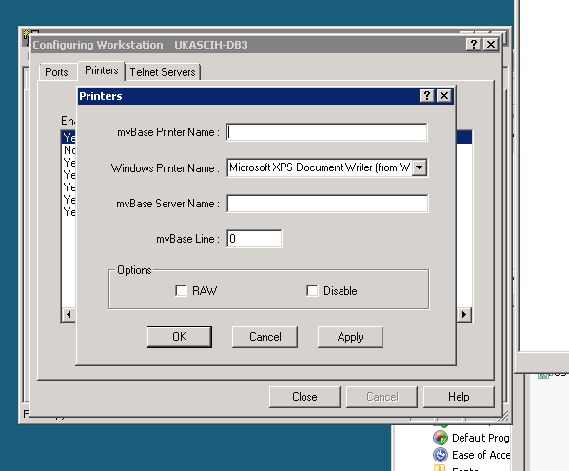
The [Printers] Dialog appears
Type in:
Chosen mvBase Printer Name
This should be the same or similar to the Windows printer name
Choose:
Windows printer name (from the drop down list)
Type in:
The correct mvBase Server name the workstation is connected to
This is NOT the ip address
Enter the chosen port number (usually in a sequence) e.g. 92-98
Ensure that the port is not used by any other device
You can check the other printers to verify this
Check the box:
RAW.
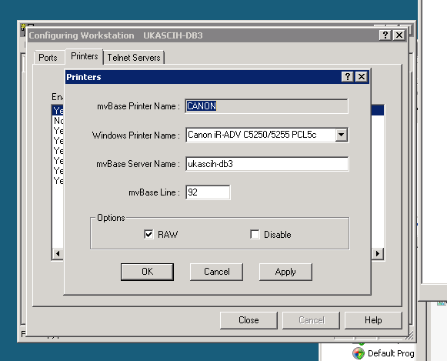
Press the [Apply] and then press the [OK] buttons.
You return to the Configure Workstation Tab
Press the [Close] button
You return to the Workstation Tab
Press the [Server] Tab
You return to the Server Tab.

Restart the Server and workstation

After the Logons have been performed, and the system is stable (VERIFY-SYSTEM) type in these commands:
ED SYSPROG-PL USER-COLD-START
Use the ‘P’ (L22) command to scroll down the PROC until you see the STARTPTR commands.
Copy (using ME command) 2 lines from an existing printer, and adapt for the new printer.
See the STARTLPTR command in the Commands Chapter.
File Item (FI) the PROC.
This will save the command every time a shutdown and startup is performed.
Type in the command you have just created at TCL
E.g. STARTPTR 30,1,0,S97 (S
This will start the printer in Pick ready to accept print commands
It will initialize the printer and allow direct printing if required.
Send a simple print to the new printer to ensure it is connected using:
SP-ASSIGN F30 HS
BLOCK-PRINT TEST PAGE FROM THE PICK SERVER (P
The words “TEST PAGE FROM THE PICK SERVER” should be printed into the spooler
To De-Spool into the printer control block type in the SP-EDIT command, and choose Spool.
e.g. SP-EDIT nn , N N Y.

