Configuring and Using the mvBase Server
The mvBase Server contains the MultiValue database and the associated processes and lines by which it is accessed and used. You must start the mvBase Server in order to use mvBase. You may (re)configure the mvBase Server at any time (whenever the Server is stopped), but some reconfigurations require that you perform a subsequent fileload when restarting the Server after reconfiguration. For additional information about daily system maintenance, see Daily System Maintenance.
Configuring the Server
mvBase Server configuration entails:
- Authorization (includes the quantity of authorized client connections)
- The quantity, size and location of virtual memory storage files
- The quantity of MultiValue processes and lines
- mvBase tape units, such as physical tape devices, virtual tape files, virtual tape links, and remote floppy devices
Operating the Server
mvBase Server operation entails:
- Server startup as an application or service
- Server shutdown
- Numerous Server operations performed at TCL
This section focuses upon Server configuration and operation from the Administration Utility and from TCL. Server (database) use has many additional facets that are documented elsewhere. For additional information about the function of the mvBase Server within mvBase architecture, see the mvBase System Overview document.
This section covers the following general topics related to the mvBase Server:
Server Tab Overview | Summarizes the components and operations of the Server tab of the Administration Utility.
Guidelines for the mvBase Server | Summarizes operational guidelines for using the mvBase Server.
Required Server Configurations
The configurations described in the next three sections must be completed prior to operating the mvBase Server:
Authorizing the mvBase Server | Describes the procedure to change the authorization status subsequent to installation/ upgrade, or changes in the number of authorized connections.
(Re)Defining Processes and Lines | Describes the procedure to alter the quantity of processes or lines on the mvBase Server.
(Re)Defining Virtual Memory Storage Files | Describes the procedure to add, delete or resize one or more virtual memory storage files.
Mapping Drives | Instructions for mapping drives for mvBase use.
Starting and Stopping the mvBase Server | Summarizes the autoboot option and manual startup, and their relation to the application and service execution modes.

Server Tab Overview
The Server tab of the Administration Utility performs several critical functions. These include starting and stopping the Server, authorizing the Server, defining virtual memory storage files, defining processes and lines, and defining mvBase tape units.
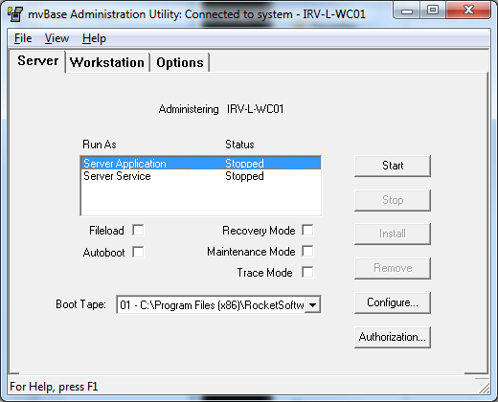
The Server tab contains many secondary dialog boxes and property sheets that perform several functions. Access the Server tab via the Administration Utility. You may then proceed in one of several directions:
If you want to... | then... | The system...
Authorize the Server | Select Authorize in the Server tab. | Displays the Authorization dialog box.
(Re)Define the quantity of processes or lines | Select Configure in the Server tab. | Displays the Configuring Server property sheet. Select the Processes + Lines tab, then select Update.
(Re)Define the quantity of virtual memory storage files | Select Configure in the Server tab. | Displays the Configuring Server property sheet. Select the Files tab.
Configure trace parameters | Select the Trace Mode check box. | Displays the Trace Configuration dialog box after the Start button is selected. This dialog allows configuring the various trace parameters before starting the mvBase server. Once the Trace Configuration dialog has been closed, the mvBase server starts with trace enabled.  WARNING- Trace Mode should only be used under the supervision of a Rocket Software support engineer.
Add or delete an mvBase tape unit | Select Configure in the Server tab. | Displays the Configuring Server property sheet. Select the Tapes tab, and proceed according to the type of tape unit you wish to add (physical, virtual, etc.).
Add or delete a remote floppy device | Select Configure in the Server tab. | Displays the Configuring Server property sheet. Select the Tapes tab, select a unit number, then select Add Remote Floppy.
Add or delete a mapped drive | Select Configure in the Server tab. | Displays the Configuring Server property sheet. Select the Resource mappings tab, then select Add.
Start the Server as an application | Select the Server Application mode in the Server tab then select Start. | Starts the mvBase Server and makes it available for connections.
Start the Server as a service | Select the Server Service mode in the Server tab then select Install and Start. | Installs the mvBase service execution mode, then starts the Server as a service and makes it available for connections.
Stop the Server | Select the current execution mode in the Server tab, then select Stop. | Stops the mvBase Server and disconnects all connected clients (if they are not previously disconnected).

Guidelines for the mvBase Server
There are a number of guidelines for operating the mvBase Server. These are repeated throughout the procedures and topics of this section, but they are listed here for quick reference and review.
Configuring the mvBase Server
- You may configure most components of the mvBase Server prior to authorization or startup.
- Before starting the mvBase Server, you must complete authorization, define virtual memory storage file(s), and define processes and lines. Other (non-default) configurations are optional.
- You must define virtual memory storage files within acceptable parameters for your version of Windows. When Windows differences affect available configurations, the differences are documented in the relevant procedures.
- The system may take a considerable amount of time to configure your hard disk drive(s) when defining virtual memory storage files. Plan accordingly.
- Most configurations of the mvBase Server require administrator rights when mvBase is installed on Windows.
- Any time you alter the quantity of mvBase processes on the Server, you must perform a fileload.
- You may alter the quantity of mvBase lines on the Server at any time without performing another fileload (if the Server is stopped). Plan your processes and lines accordingly.
Operating the mvBase Server
- When starting the Server for the first time (after installation or upgrade), you must start the Server as an application with a fileload.
- You should start the Server prior to starting and connecting the mvBase Workstation or any clients.
- You may execute the Server as an application or service in Windows.
- You should check for client connections every time you plan to shut down the Server (e.g., execute LISTLINES at TCL to view client connections).
Whenever you start mvBase, several diagnostic tests run:
- File systems are automatically checked.
- A number of automatic processes initiate (such as error logging, process accounting, and the Spooler).
- The system readies itself for users (clients) to connect and log on.
When you shut down the system, you must terminate automatic processes, and close down the file systems correctly to ensure that no disk drive activity is occurring when you shut off the power.
Configuring and Operating the mvBase Workstation
Because the mvBase Workstation must be operated in conjunction with the mvBase Server, this topic summarizes guidelines for operating the Workstation.
- You must define at least one COM port, printer or mvTelnet Server in order to start the Workstation.
- You should start the Server prior to starting and connecting the mvBase Workstation or any clients.
- Do not start the Workstation as an application when the Server is running as a service.
- You should check for client connections every time you plan to shut down the Workstation (e.g., issue LISTLINES at TCL to view client connections).
- Try to coordinate client line consumption following these general guidelines. These will help prevent premature line consumption by an unexpectedly high volume of wildcard (first available line) clients.
- Allocate the higher line numbers to printers and terminal devices, which will only consume one line per client.
- Allocate the midrange of line numbers to line-pooling clients.
- Allocate the lowest line numbers to wildcard clients. These clients start at the lowest line number and search upward, taking the first available line upon connect.

Authorizing the mvBase Server
To authorize the mvBase Server:
- You must first install or upgrade mvBase.
- You must have an authorization code (temporary or permanent).
You may configure most components of the mvBase Server prior to authorization, but authorization is required for Server startup.
NOTE | When authorizing mvBase with a temporary authorization code, the authorization expires in 14 days. A permanent authorization code will be required. Obtain a permanent code from a representative of Rocket.
Perform these steps to authorize the mvBase Server:
- Launch or switch to the Administration Utility, which may be accessed via the Windows Task bar.
- Select the Server tab if it is not displayed.
- Select Authorization. The mvBase Authorization dialog box displays. The Authorization Code field displays the current status of unauthorized, and a unique System ID.
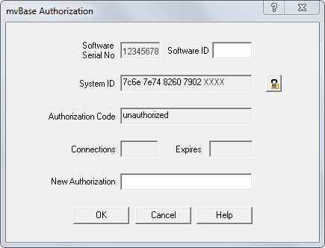
- Enter the authorization code in the New Authorization field. The means to obtain the authorization code depends on whether this is a first-time installation, an upgrade from an earlier release, or an increase in the number of authorized connections.
  - For first-time installation of mvBase, you may use a temporary authorization code. This is located on the CD-ROM jewel case insert or on one or more of the floppy diskettes.
  - When installing mvBase with a temporary authorization code, the authorization expires in 14 days. Obtain a permanent code from a representative of Rocket. When you procure a new permanent authorization code, Rocket’s Order Administration requires the System ID listed in the mvBase Authorization dialog box, which you access via the Authorization button as in step 3 above.
  - When an increase in the number of authorized connections is required, obtain a new permanent authorization code from a representative of Rocket by purchasing additional licenses.
- Click OK. A confirmation message box displays with the maximum quantity of simultaneous connections and expiry date (if applicable).
- Click OK. The Server tab displays for additional configuration or startup, or you may close the Administration Utility.

(Re)Defining Processes and Lines
mvBase installation/upgrade defines 16 processes and 16 lines (by default). A fileload is required whenever you alter the quantity of processes. You may wish to configure many more processes than lines initially. This allows for future growth in connections (lines) without having to perform another fileload. Perform these steps to alter the quantity of mvBase processes or lines:
- Perform a full filesave.
- Launch or switch to the Administration Utility.
- Select the Server tab if it is not in the foreground.
- Ensure that the Server has no connected clients.
- Stop the Server Application or Server Service if required. Server Application and Server Service status fields should display Stopped or Uninstalled.
- Ensure that the Boot Tape field specifies either:
  - The tape device in which the filesave media is loaded or
  - The virtual tape file containing the filesave (the device with the filesave tape)
- Select Configure. The Configuring Server dialog box displays.

(Re)Defining Processes and Lines
mvBase installation/upgrade defines 16 processes and 16 lines (by default). A fileload is required whenever you alter the quantity of processes. You may wish to configure many more processes than lines initially. This allows for future growth in connections (lines) without having to perform another fileload. Perform these steps to alter the quantity of mvBase processes or lines:
- Perform a full filesave.
- Launch or switch to the Administration Utility.
- Select the Server tab if it is not in the foreground.
- Ensure that the Server has no connected clients.
- Stop the Server Application or Server Service if required. Server Application and Server Service status fields should display Stopped or Uninstalled.
- Ensure that the Boot Tape field specifies either:
  - The tape device in which the filesave media is loaded or
  - The virtual tape file containing the filesave (the device with the filesave tape)
- Select Configure. The Configuring Server dialog box displays.
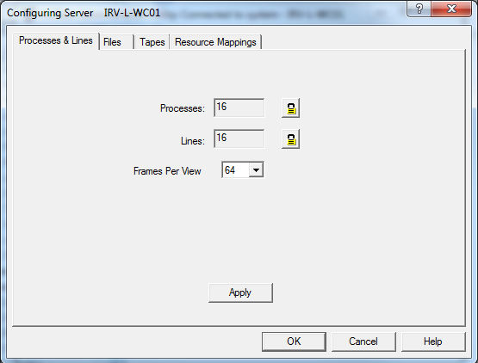
- Select the Processes & Lines tab if it is not displayed in the foreground.
- Click the Lock icon next to the field you want to update.
One of the following warning messages displays:
If updating Processes, a warning displays indicating that changing the number of processes requires a fileload and that a reduction in the number of processes can adversely affect existing Workstation configurations.
If updating Lines, a warning displays indicating that a reduction in the number of lines can adversely affect existing Workstation configurations.
- Click Yes if you want to Continue, and then enter the new value in the now editable text box. Use the table below as a guide:
Processes | Number of configured mvBase Server processes. Upon startup of mvBase Server, a number of frames will be allocated and initialized from the first virtual memory storage file. These frames are used to hold each process control blocks, primary and secondary workspaces.  Enter the number of mvBase Server processes to be configured. Changing the number of processes will require that a fileload be performed at the mvBase Server startup since the frames used to hold these processes are allocated before the frames used by the database. Values of 1-1023 are allowed and are independent of the number of connections that the mvBase Server has been authorized. Configuring more processes than authorized connections would allow for future authorization of additional connections to the mvBase Server without having to perform a Fileload. Also, increasing the number of processes may require the size of the 1st VMS file to be increased to hold the new processes.
Lines | Number of configured mvBase Server lines that will be available for mvBase client connections at mvBase Server startup.  Enter the number of mvBase Server lines to configure. Changing the number of lines does not cause a fileload but may affect the behavior of configured mvBase Workstations.  Values of 1-1023 are allowed. Increasing the number of mvBase Server lines will allow more licensed connections to be made to the mvBase Server without requiring any configuration changes to any mvBase Workstations. However, decreasing the number of mvBase Server lines may cause configured workstations to reference a line that will not be available at Server startup.
Frames Per View | Defines the number of frames that are mapped into memory at a time from the non-primary virtual memory storage (VMS) files. Changes to this field require a reboot of the mvBase server before taking effect.
- Click Apply. A message displays confirming the values were successfully updated.
- Click OK.
- Click OK in the Configuring Server dialog box.
- (Re)Start the Server once all desired components are configured. A fileload is required if you changed the quantity of mvBase processes, but not if you changed the quantity of lines only.
The number of processes and lines are independent and are initially linked at startup with process n linked to line n. Configurations with more processes than lines will leave the excess processes unlinked and available as phantom processes. Configurations with more lines than processes will leave the excess lines unlinked and available for use by the LINE-ATT command.

Mapping Drives
You can map drives for mvBase use from the Resource Mappings tab.
To map a drive:
- In the Configuring Server dialog box select the Resource Mappings tab.
- Click Add.
- In the Add Mapping dialog box, type the drive letter for the drive being mapped in the Local Path text box.
- Type the directory within the specified drive letter for the drive being mapped in the Remote Path text box.
- Click OK.
The mapping is added to the list of mappings in the Resource Mappings tab. To remove a mapping, select the mapping from the list of mappings and click Remove.

- Select the Processes & Lines tab if it is not displayed in the foreground.
- Click the Lock icon next to the field you want to update.
One of the following warning messages displays:
If updating Processes, a warning displays indicating that changing the number of processes requires a fileload and that a reduction in the number of processes can adversely affect existing Workstation configurations.
If updating Lines, a warning displays indicating that a reduction in the number of lines can adversely affect existing Workstation configurations.
- Click Yes if you want to Continue, and then enter the new value in the now editable text box. Use the table below as a guide:
Processes | Number of configured mvBase Server processes. Upon startup of mvBase Server, a number of frames will be allocated and initialized from the first virtual memory storage file. These frames are used to hold each process control blocks, primary and secondary workspaces.  Enter the number of mvBase Server processes to be configured. Changing the number of processes will require that a fileload be performed at the mvBase Server startup since the frames used to hold these processes are allocated before the frames used by the database. Values of 1-1023 are allowed and are independent of the number of connections that the mvBase Server has been authorized. Configuring more processes than authorized connections would allow for future authorization of additional connections to the mvBase Server without having to perform a Fileload. Also, increasing the number of processes may require the size of the 1st VMS file to be increased to hold the new processes.
Lines | Number of configured mvBase Server lines that will be available for mvBase client connections at mvBase Server startup.  Enter the number of mvBase Server lines to configure. Changing the number of lines does not cause a fileload but may affect the behavior of configured mvBase Workstations.  Values of 1-1023 are allowed. Increasing the number of mvBase Server lines will allow more licensed connections to be made to the mvBase Server without requiring any configuration changes to any mvBase Workstations. However, decreasing the number of mvBase Server lines may cause configured workstations to reference a line that will not be available at Server startup.
Frames Per View | Defines the number of frames that are mapped into memory at a time from the non-primary virtual memory storage (VMS) files. Changes to this field require a reboot of the mvBase server before taking effect.
- Click Apply. A message displays confirming the values were successfully updated.
- Click OK.
- Click OK in the Configuring Server dialog box.
- (Re)Start the Server once all desired components are configured. A fileload is required if you changed the quantity of mvBase processes, but not if you changed the quantity of lines only.
The number of processes and lines are independent and are initially linked at startup with process n linked to line n. Configurations with more processes than lines will leave the excess processes unlinked and available as phantom processes. Configurations with more lines than processes will leave the excess lines unlinked and available for use by the LINE-ATT command.

Mapping Drives
You can map drives for mvBase use from the Resource Mappings tab.
To map a drive:
- In the Configuring Server dialog box select the Resource Mappings tab.
- Click Add.
- In the Add Mapping dialog box, type the drive letter for the drive being mapped in the Local Path text box.
- Type the directory within the specified drive letter for the drive being mapped in the Remote Path text box.
- Click OK.
The mapping is added to the list of mappings in the Resource Mappings tab. To remove a mapping, select the mapping from the list of mappings and click Remove.

